ANNEXURE A



ANNEXURE B

ANNEXURE C

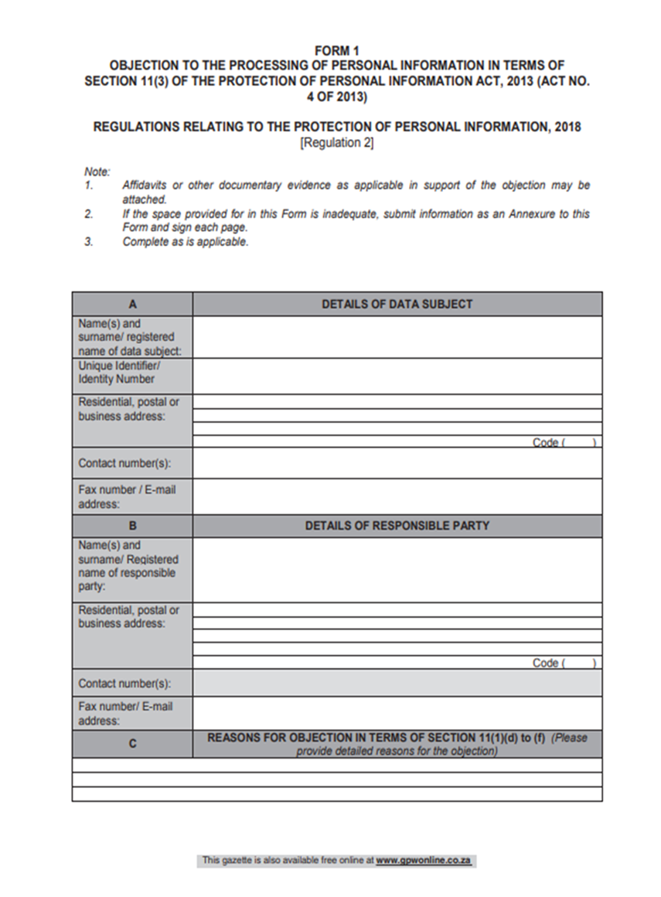



ANNEXURE D

